COMSATS University Islamabad

Applications of Information and Communication Technologies

Lab No. 05

Introduction to HTML

|  |  |
| --- | --- |
| Name | Ali Haider |
| Registration Number | FA24-BCE-018 |
| Class | CS101- AICT |
| Instructor’s Name | Khuram Ali |

**Date: 18th-october -2024**

**PART 01:**

**Introduction to HTML:**

**Objective:**

The objective of this lab report is to gain a foundational understanding of HTML (Hypertext Markup Language) and learn how to design and structure web pages.

**Equipment:**

The following equipment is used

* VS Code
* MS Word

**Introduction:**

HTML is the primary markup language used for building web pages. It establishes the core structure of a webpage, which can be further styled and enhanced using technologies like CSS and JavaScript. In this lab, we will explore how to construct a simple webpage using various HTML tags and elements.

**Lab Task 1:  
 Objective:** Learn and apply different HTML tags and formatting options on a simple webpage about **Comsats University**.:

**Steps:**

1. Create a New HTML File
2. Start Writing that code in that file
3. <html>
4. <head>
5. <meta charset="UTF-8">
6. <meta name="viewport" content="width=device-width, initial-scale=1.0">
7. <title>Comsats University</title>
8. </style>
9. </head>
10. <body>
11. <header>
12. <h1>Comsats University Islamabad</h1>
13. <p> Where Education Leads to Excellence</p>
14. </header>
15. <section>
16. <h2>Introduction</h2>
17. <p><strong>Comsats University Islamabad (CUI)</strong> is a leading institution of higher education in Pakistan.</p>
18. <p>We offer a wide range of <em>bachelor's, master's, and doctoral</em> programs.</p>
19. <h3>Popular Programs:</h3>
20. <ul>
21. <li>Computer Science</li>
22. <li>Engineering</li>
23. <li>Business Administration</li>
24. <li>Environmental Sciences</li>
25. </ul>
26. <h3>Campus Locations:</h3>
27. <ol>
28. <li>Islamabad</li>
29. <li>Lahore</li>
30. <li>Wah</li>
31. <li>Attock</li>
32. </ol>
33. <h2>Departments</h2>
34. <table border="1" cellpadding="10">
35. <tr>
36. <th>Department</th>
37. <th>Programs</th>
38. </tr>
39. <tr>
40. <td>Computer Science</td>
41. <td>BS, MS, PhD</td>
42. </tr>
43. <tr>
44. <td>Engineering</td>
45. <td>BE, ME, PhD</td>
46. </tr>
47. <tr>
48. <td>Management Sciences</td>
49. <td>BBA, MBA, MS</td>
50. </tr>
51. </table>
52. <blockquote>
53. "The best way to predict the future is to create it." – Abraham Lincoln
54. </blockquote>
55. <h2>Contact Information</h2>
56. <p>If you have any queries, feel free to <a href="mailto:info@comsats.edu.pk">email us</a>.</p>
57. <hr>
58. <address>
59. <strong>Comsats University Islamabad</strong><br>
60. Park Road, Tarlai Kalan<br>
61. Islamabad, Pakistan
62. </address>
63. <footer>
64. <p>&copy; 2024 Comsats University Islamabad</p>
65. </footer>
66. </section>
67. </body>
68. </html>

End Result :

10/17/24, 10:42 PM Comsats University

# Comsats University Islamabad

Where Education Leads to Excellence

## Introduction

**Comsats University Islamabad (CUI)** is a leading institution of higher education in Pakistan.

We offer a wide range of *bachelor's, master's, and doctoral* programs.

**Popular Programs:**

Computer Science

Engineering

Business Administration Environmental Sciences

**Campus Locations:**

1. Islamabad
2. Lahore
3. Wah
4. Attock

## Departments

**Department**

**Programs**

Computer Science

BS, MS, PhD

Engineering

BE, ME, PhD

Management Sciences

BBA, MBA, MS

"The best way to predict the future is to create it." – Abraham Lincoln

## Contact Information

If you have any queries, feel free to email us.

***Comsats University Islamabad***

*Park Road, Tarlai Kalan*

*Islamabad, Pakistan*

© 2024 Comsats University Islamabad

**Lab Task 2 and 3**

**•** Create a webpage for Comsats library. Add lists and apply text formatting to your page. Use videos and images of the library and then add them to your page.

**HTML CODE: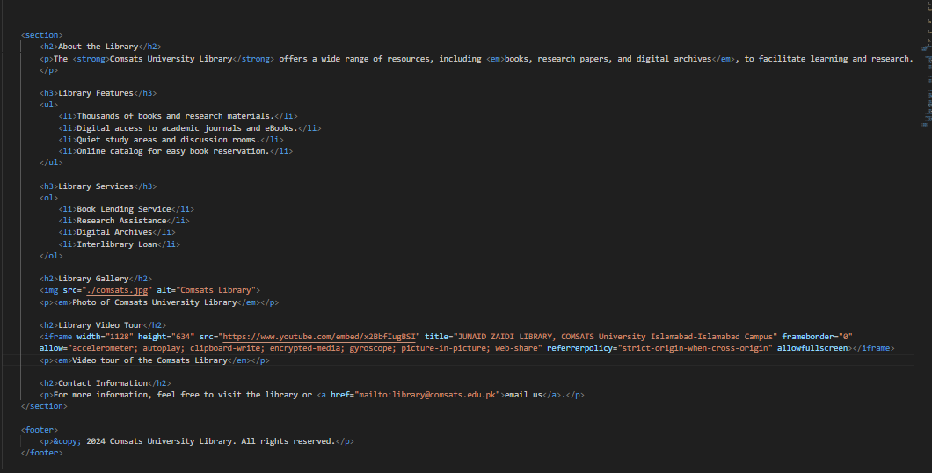CSS Code:**

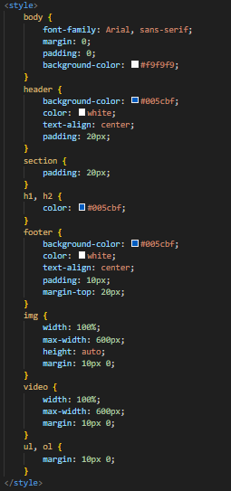

Figure CSS for lab 2

**End Results:  
**

Figure The Results of Lab 2

Figure The Results of Lab 2

**Lab Task 4:**

**HTML CODE :**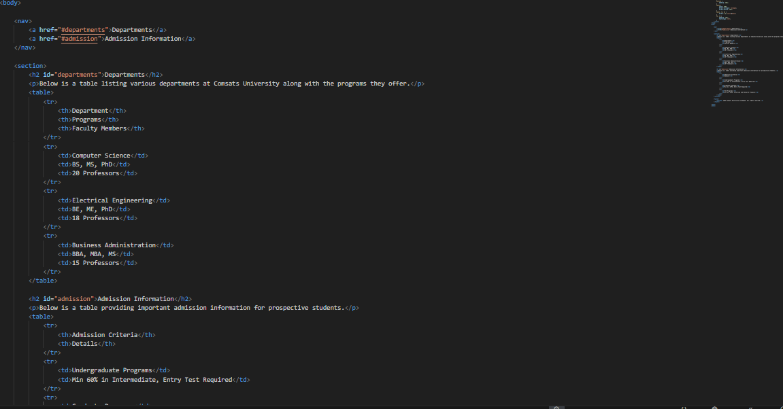

**End Results:**

**Lab Task 5:**

**End results:**

